Lesson 04 Demo 08

Scaling Up Azure App Service

Objective: To scale up Azure App Service and configure autoscaling

Tools required: Azure account with administrator access
Prerequisites: None

Steps to be followed:
- Create App Service
- Scale Up App Service

Step 1: Create App Service

- Sign into the Azure portal and click on + Create a resource

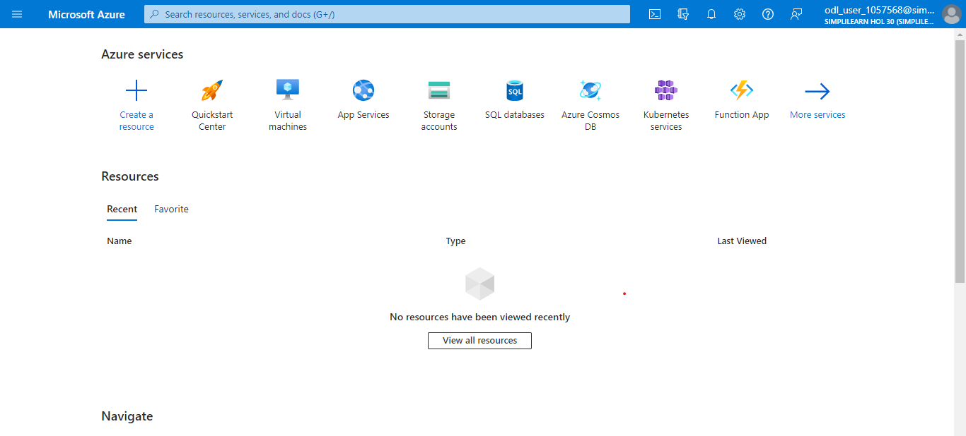

1.2 Search for App Service Plan and click on Create

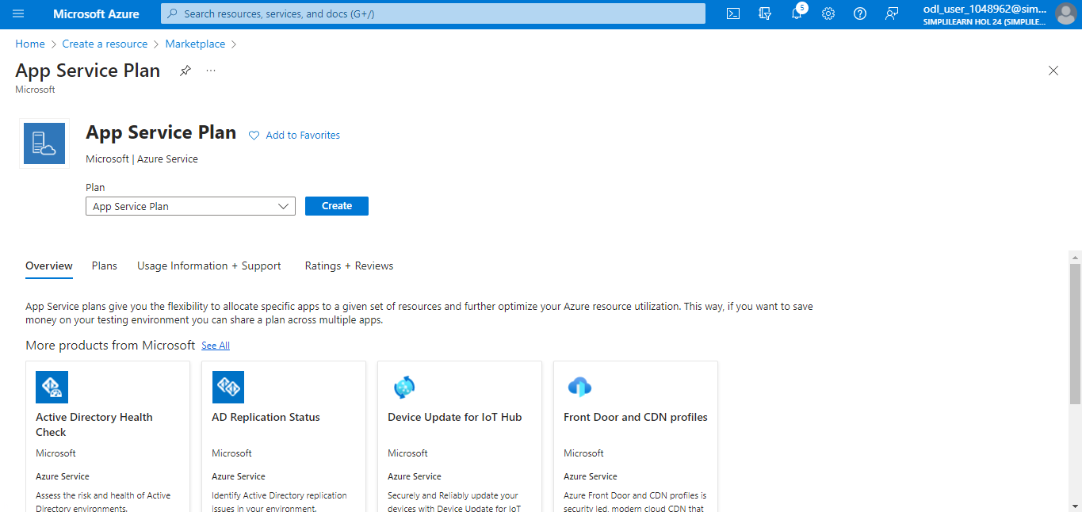

  - Under the Basics tab, provide the following details:
Subscription: Choose your subscription
Resource Group: RG01 (Create new)
Name: appserviceplan01
Operating System: Linux
Region: East US Keep the rest of the details as defaults and click on Review + create
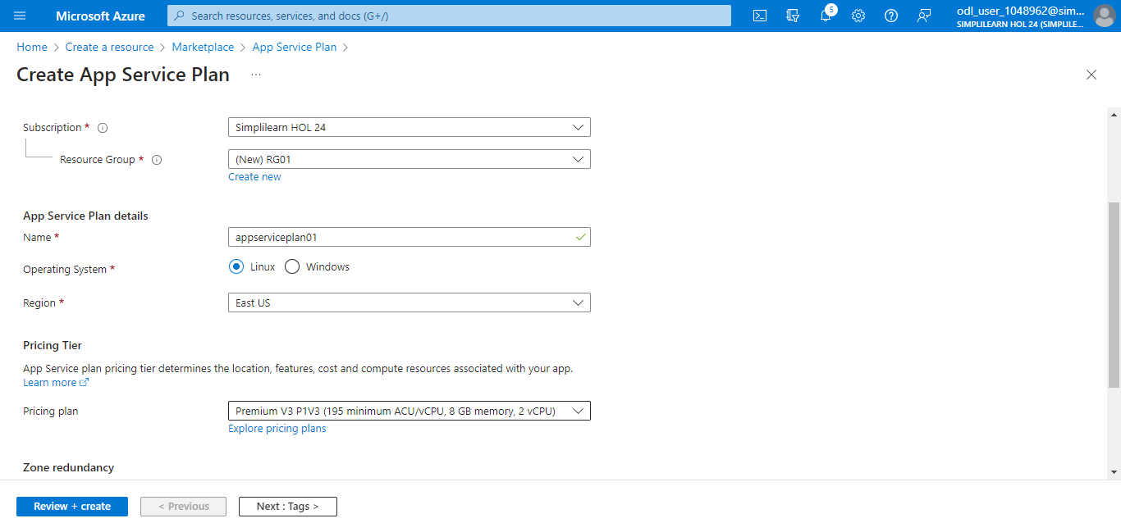

  - Click on Create

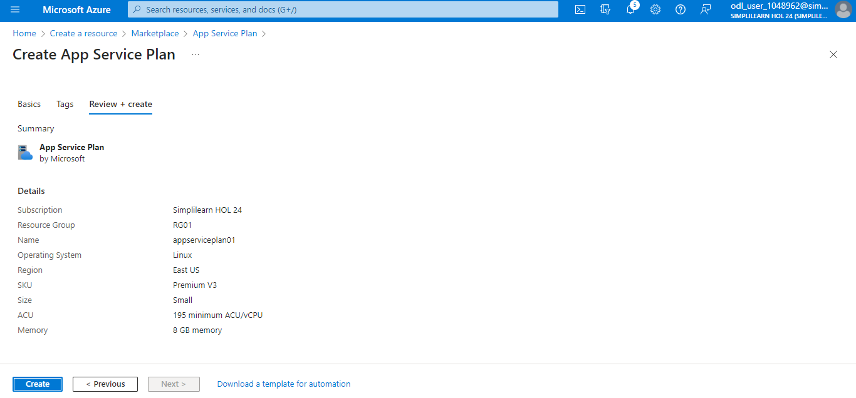

  - Click + Create a resource on the home page



  - Search for Web App and click on Create

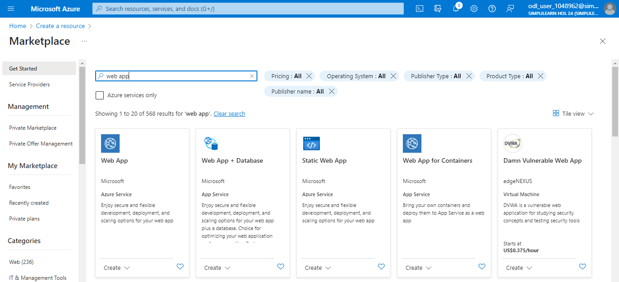

  - Provide the following details and click on Review + create
Subscription: Choose your subscription
Resource Group RG01
Name: mywebappxx (unique)
Publish: Code
Operating System: Linux
Leave the rest of the settings as default, and specify the App Service Plan created in the previous step

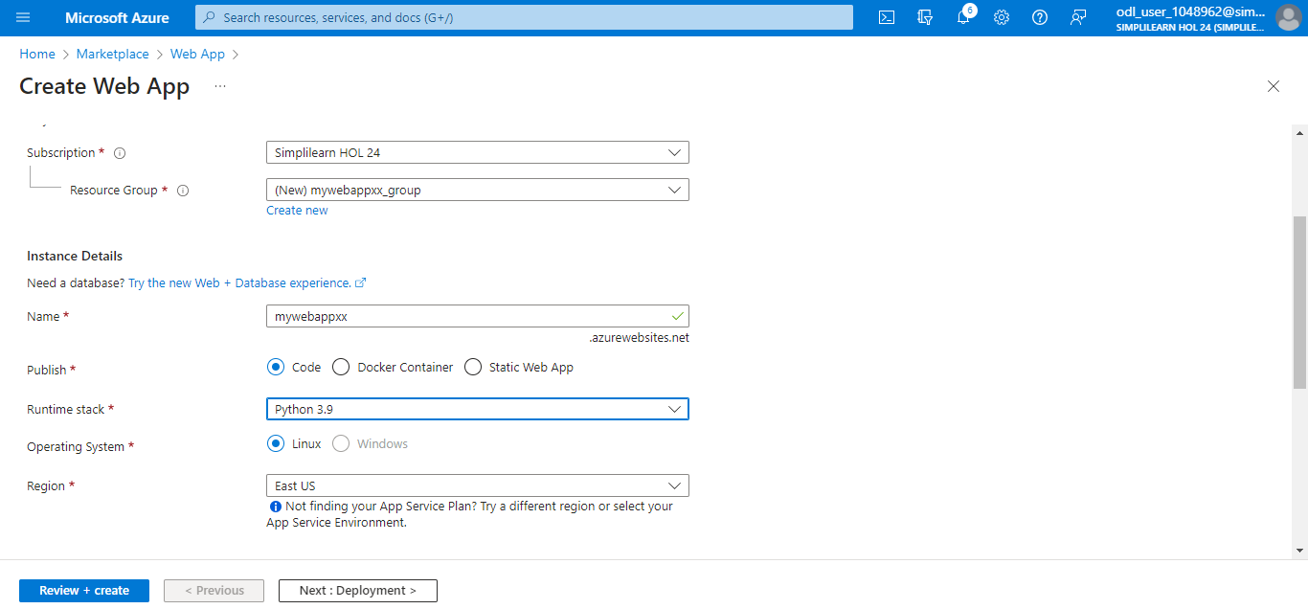

1.8 Click on Create

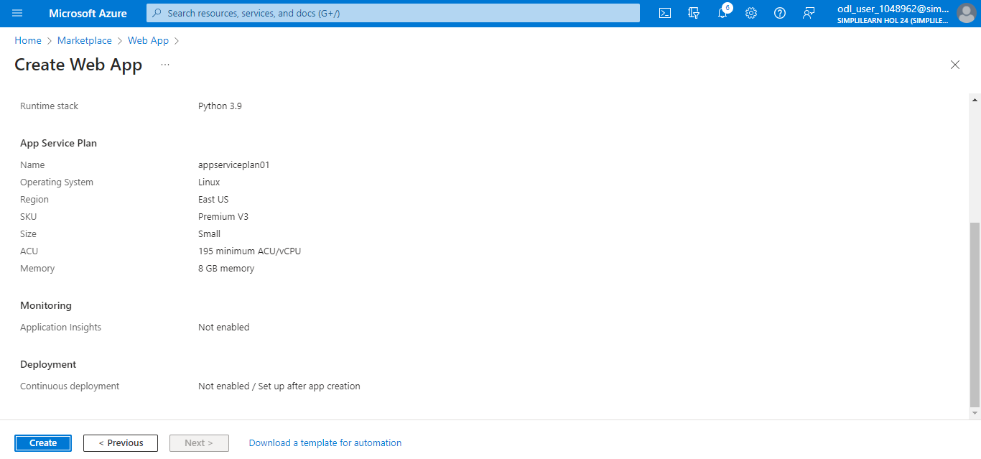

The following screenshot appears after you click on Create:

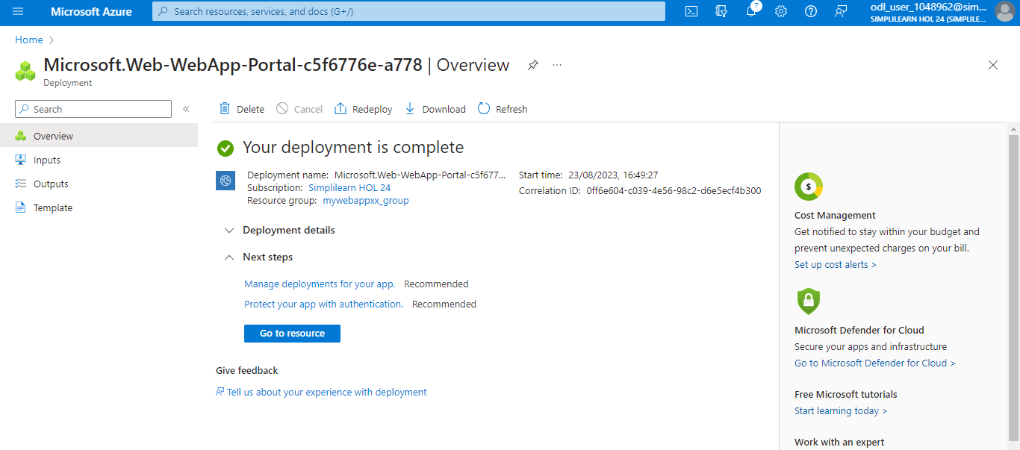

Step 2: Scaling up App Service

  - Go to the App Service resource created

  - Select Scale up (App Service plan)

  - From the window that appears, choose the required pricing tier and click Select

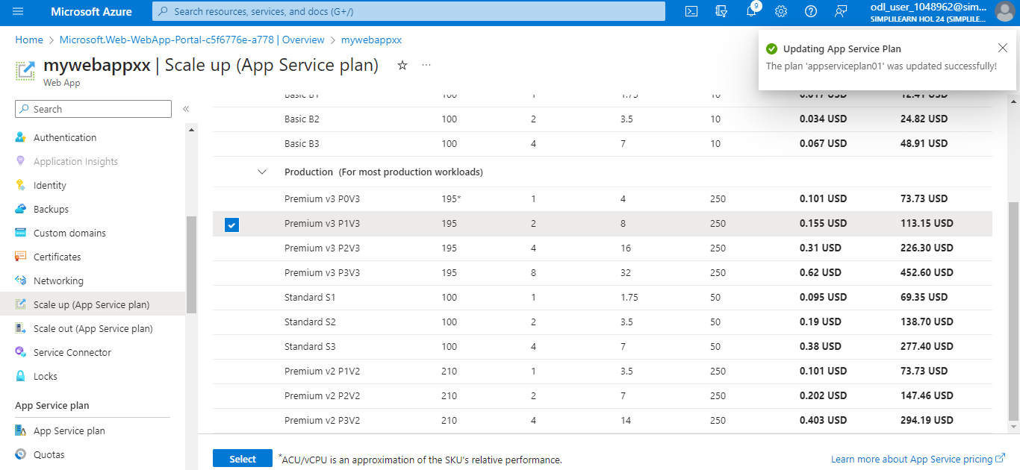

You have now successfully created an App Service and configured autoscaling.

